
3-in-1 Combo
Gift Set Catalogue

ROBUST GIFTING | Premium Corporate Gifting Solutions
27 Premium Designs | Prices exclusive of 18% GST
Cardholder Sets · Wallet Sets · Combo Acc

Item No. 01  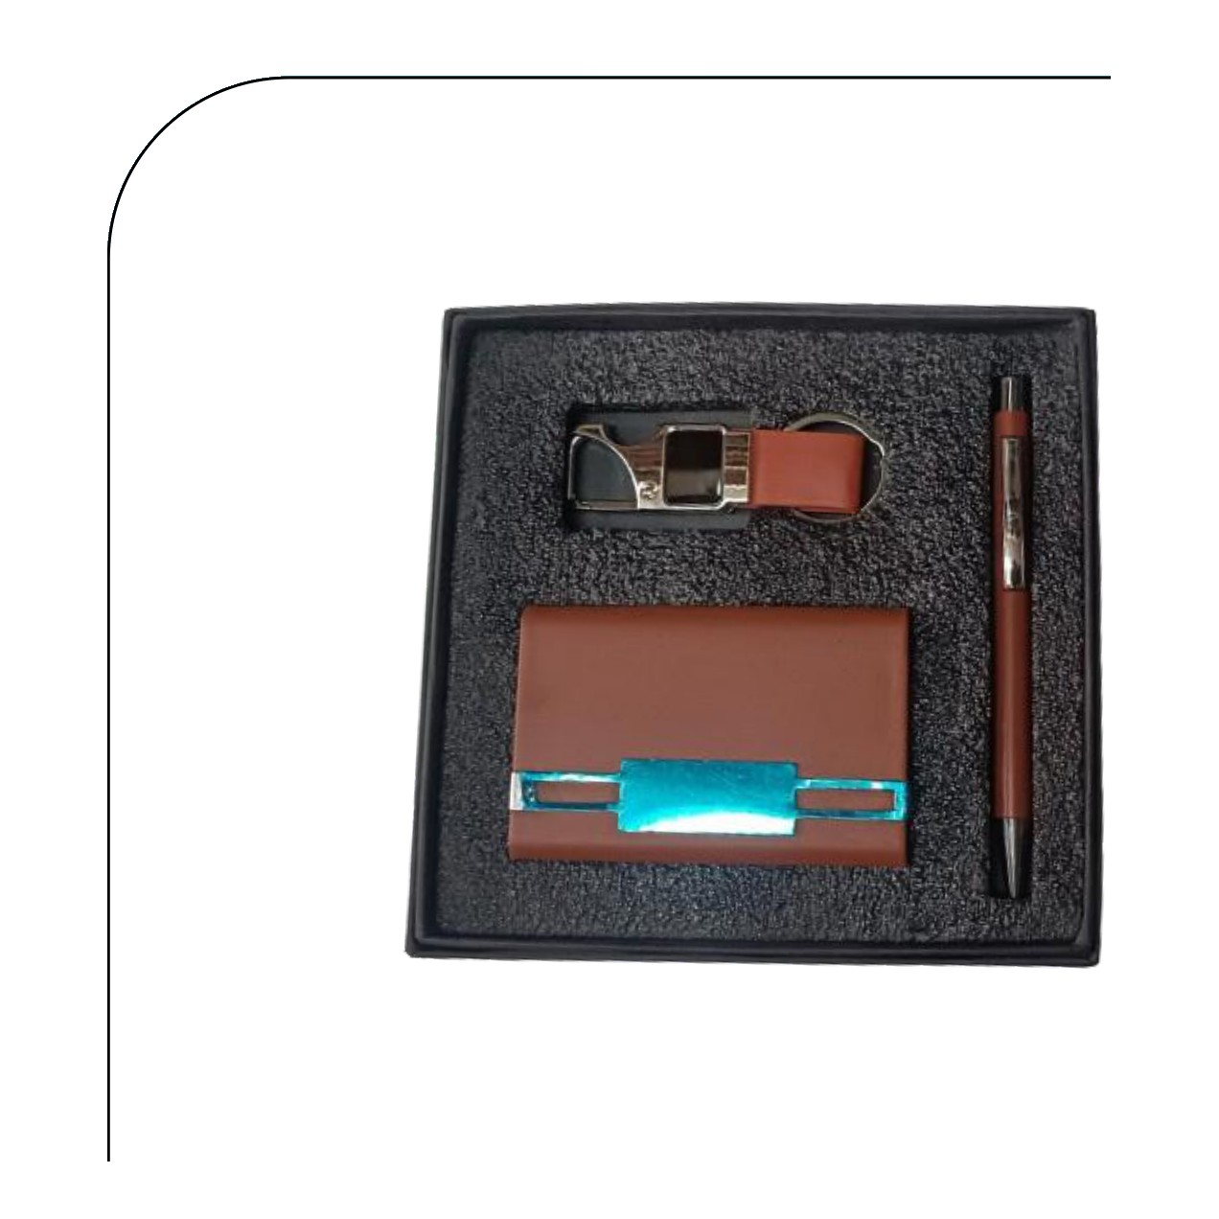  Cardholder · Pen · Hook Keychain  Rs. 177/- (Base Rs.150 + 18% GST) |  | Item No. 02  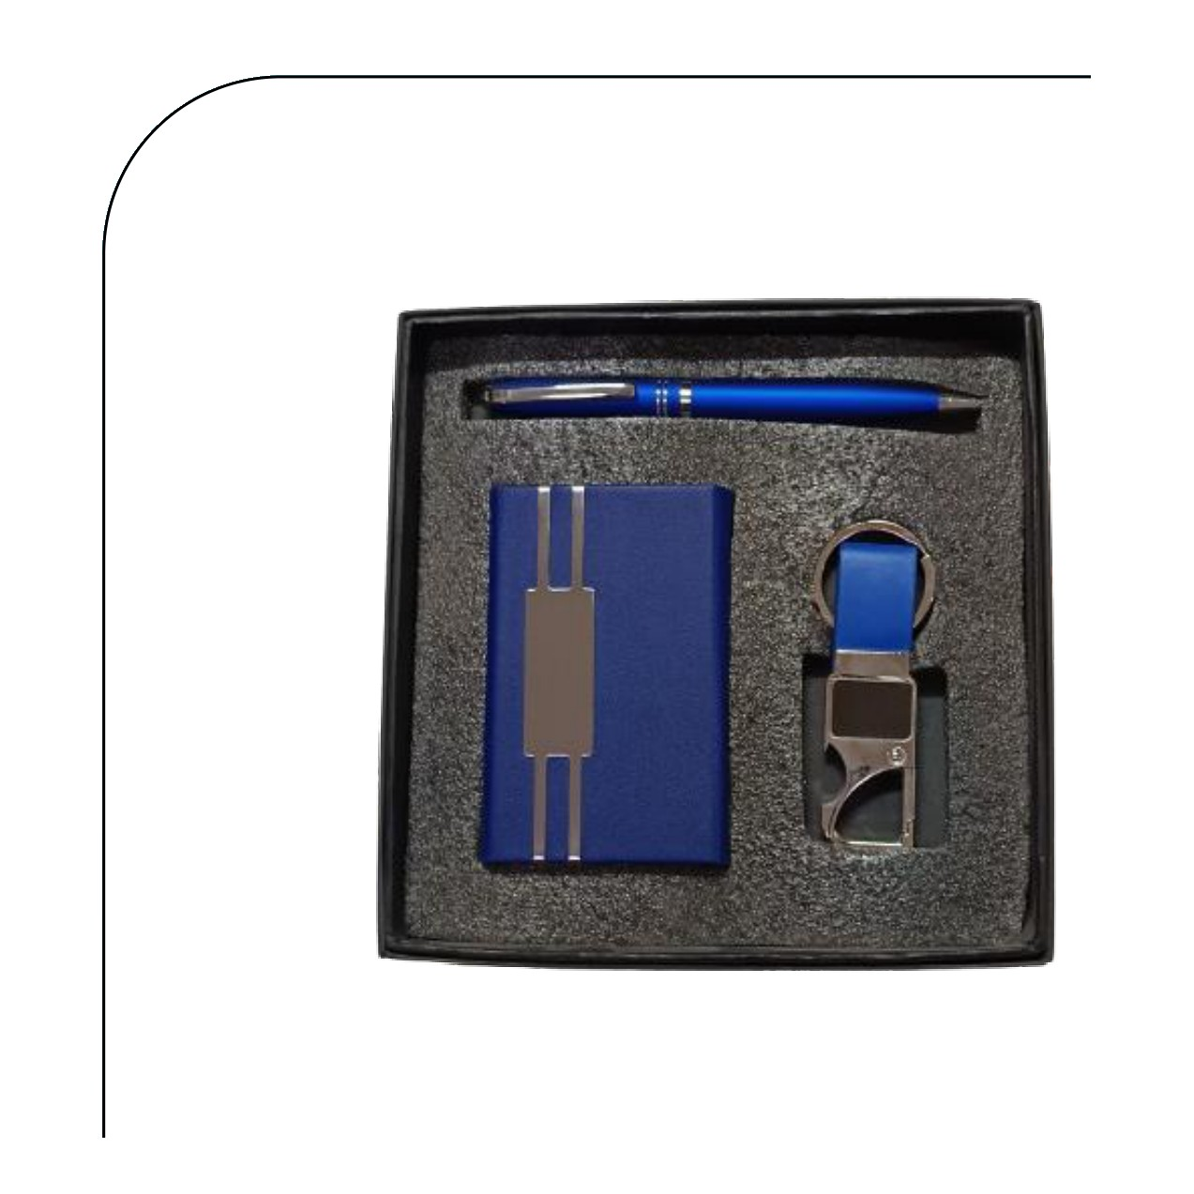  Cardholder · Pen · Hook Keychain  Rs. 177/- (Base Rs.150 + 18% GST)
Item No. 03  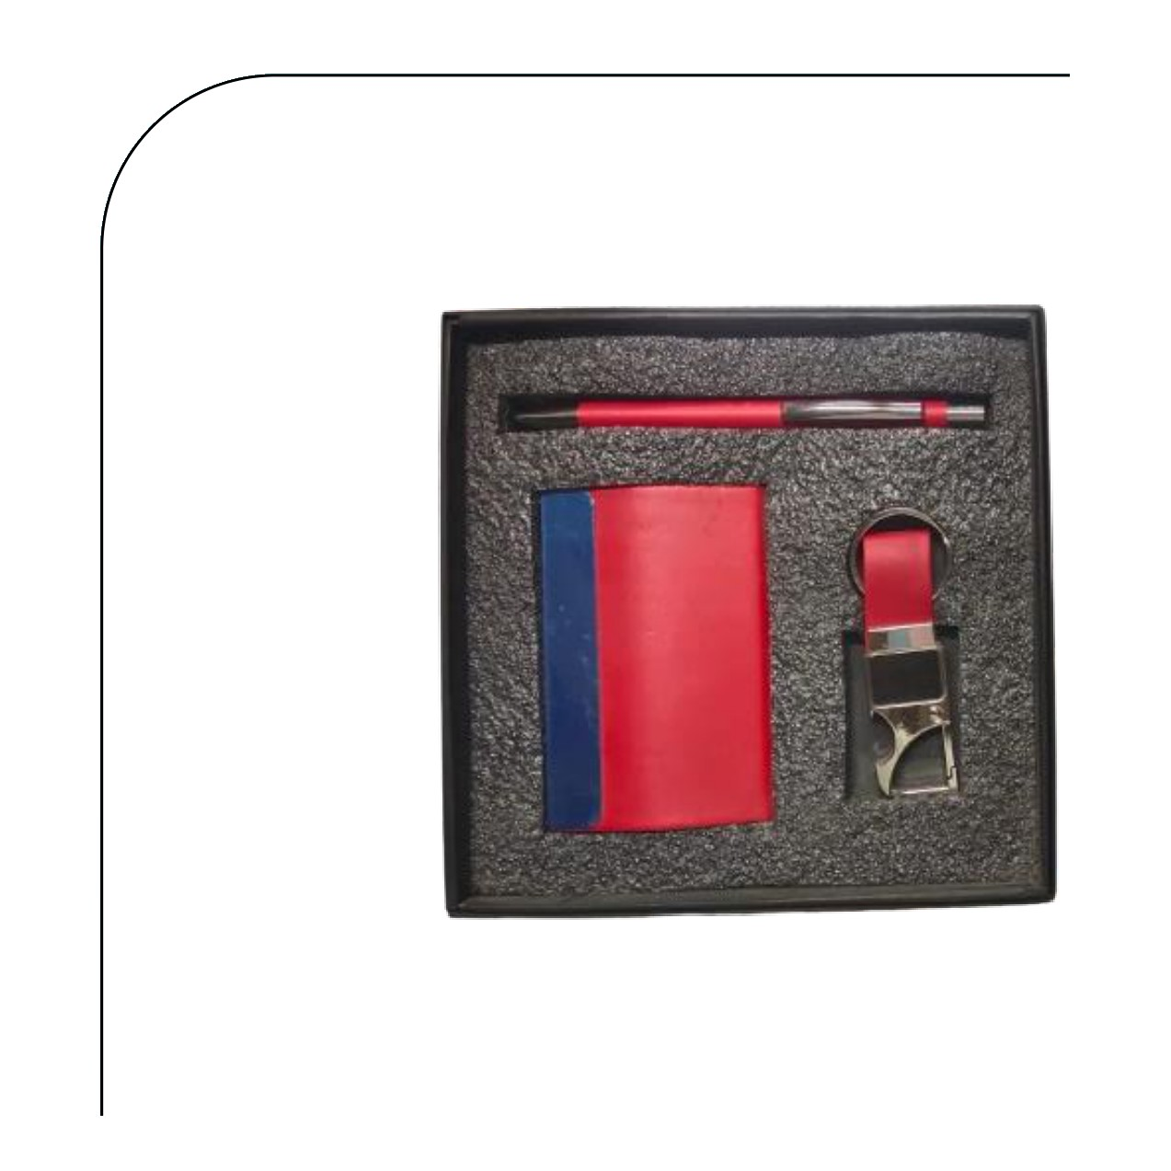  Cardholder · Pen · Hook Keychain  Rs. 159/- (Base Rs.135 + 18% GST) |  | Item No. 04  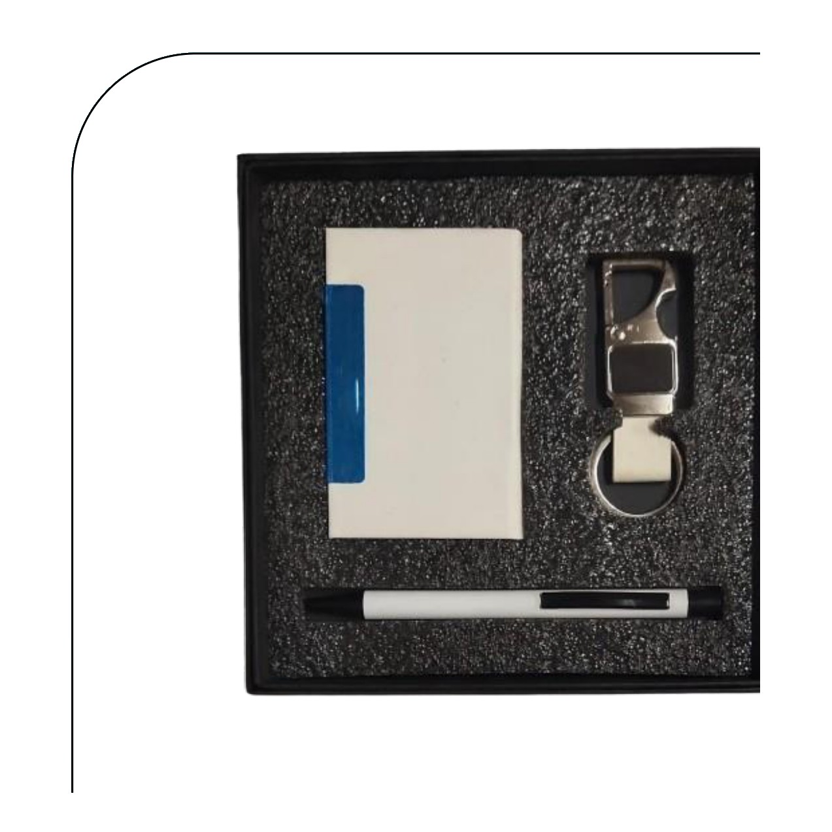  Cardholder · Pen · Hook Keychain  Rs. 159/- (Base Rs.135 + 18% GST)
Item No. 05  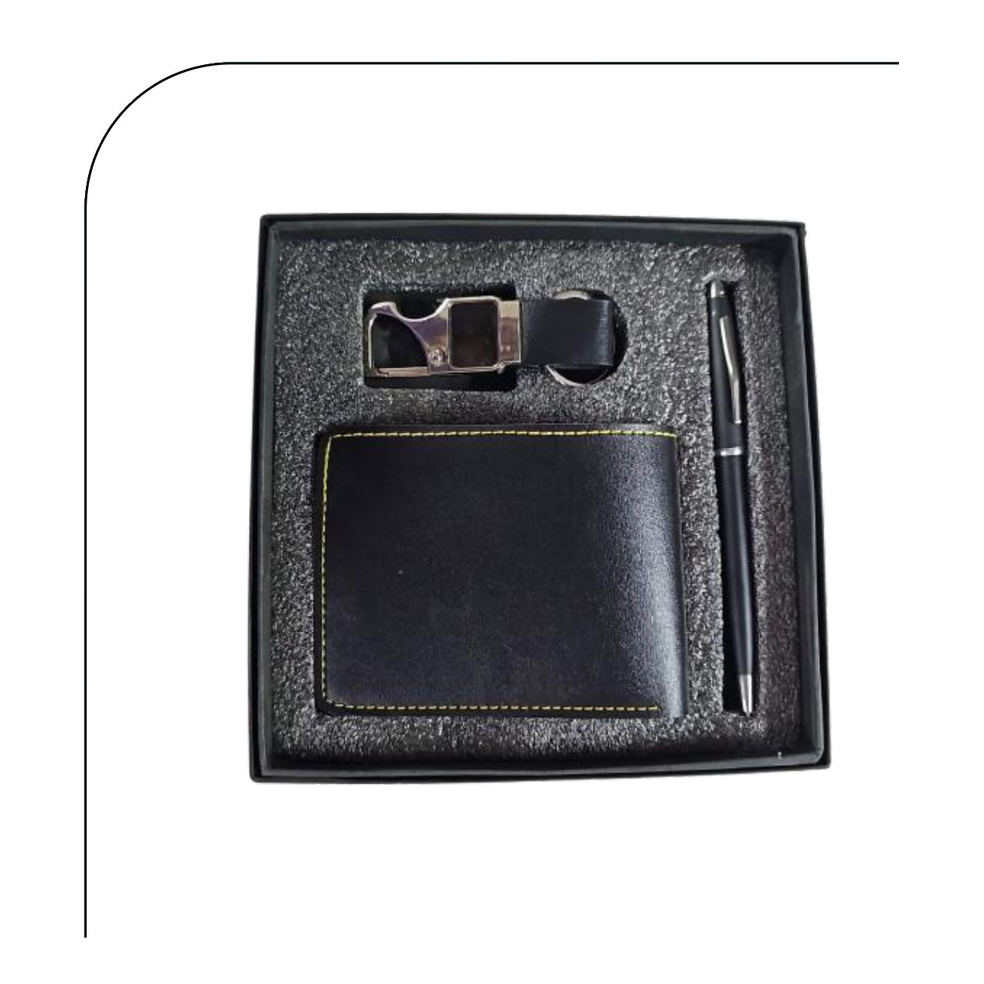  Wallet · Pen · Hook Keychain  Rs. 218/- (Base Rs.185 + 18% GST) |  | Item No. 06  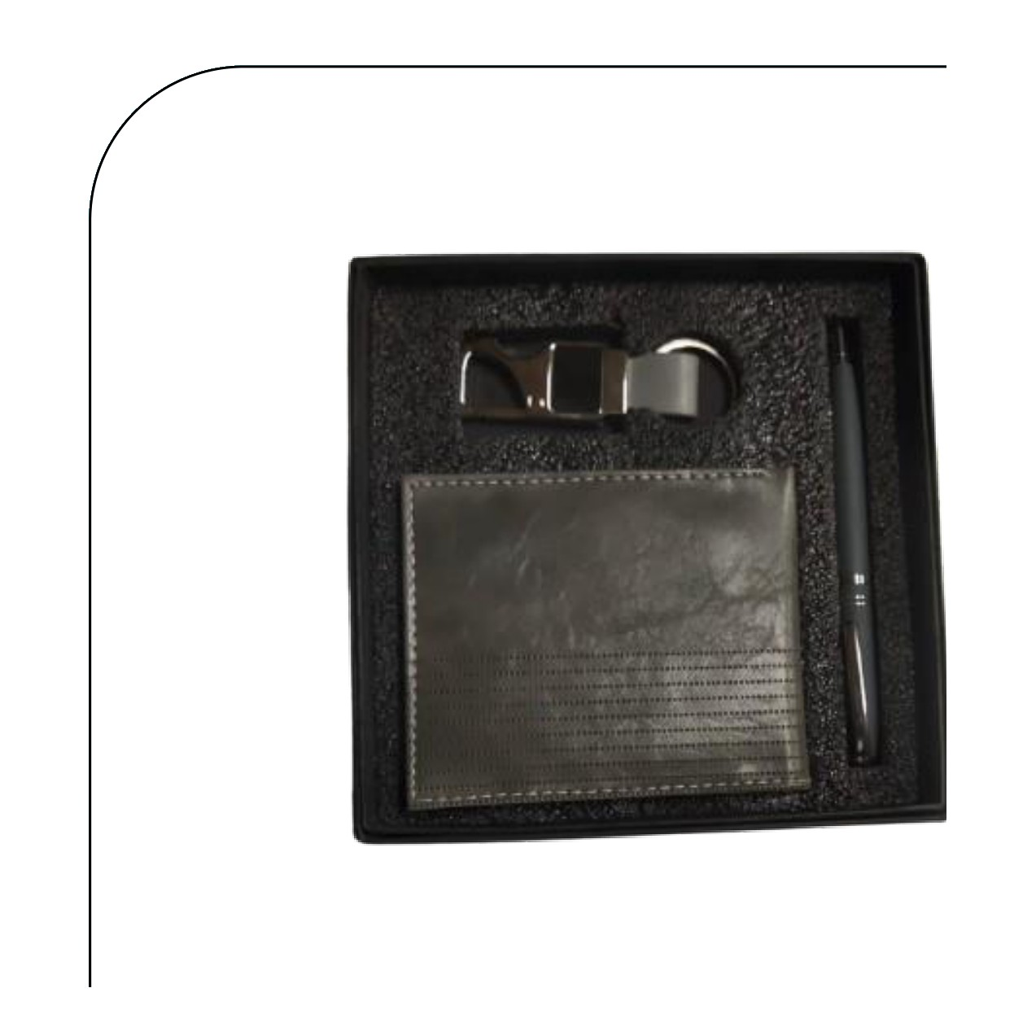  Wallet · Pen · Hook Keychain  Rs. 218/- (Base Rs.185 + 18% GST)
Item No. 07  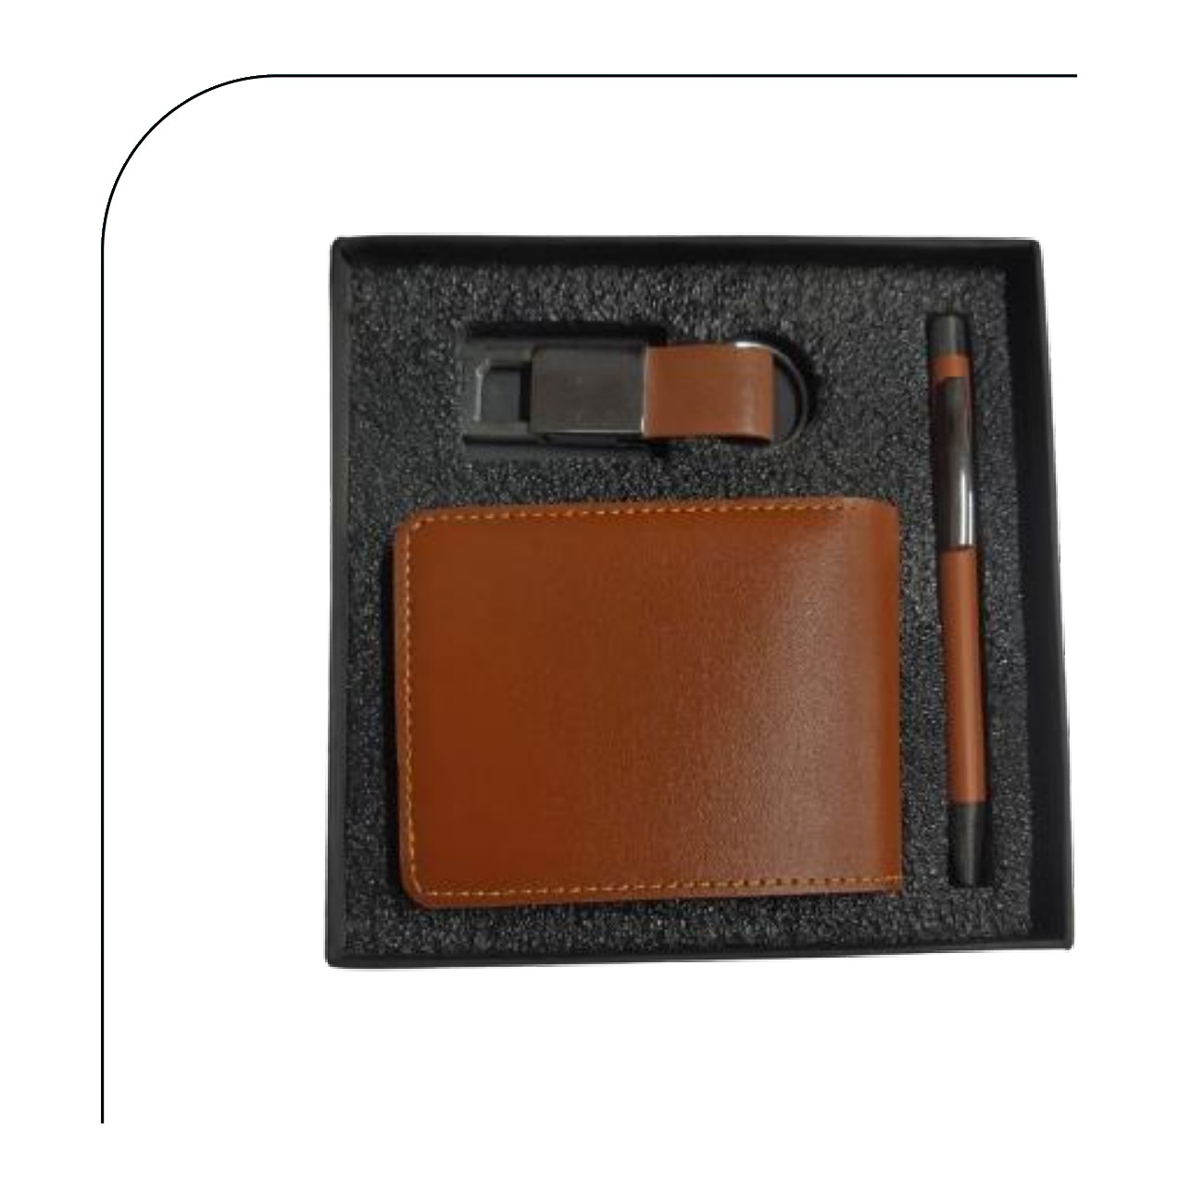  Wallet · Pen · Keychain  Rs. 218/- (Base Rs.185 + 18% GST) |  | Item No. 08  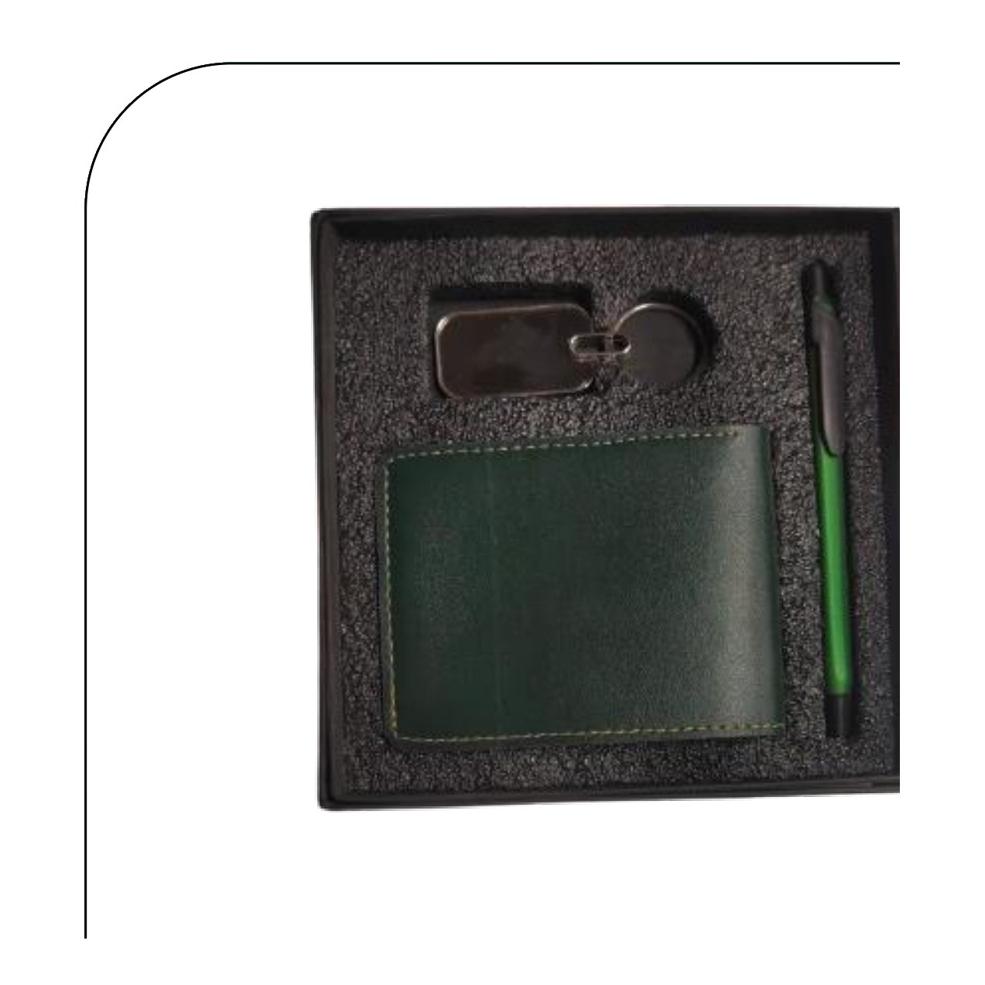  Wallet · Pen · Keychain  Rs. 201/- (Base Rs.170 + 18% GST)
Item No. 09  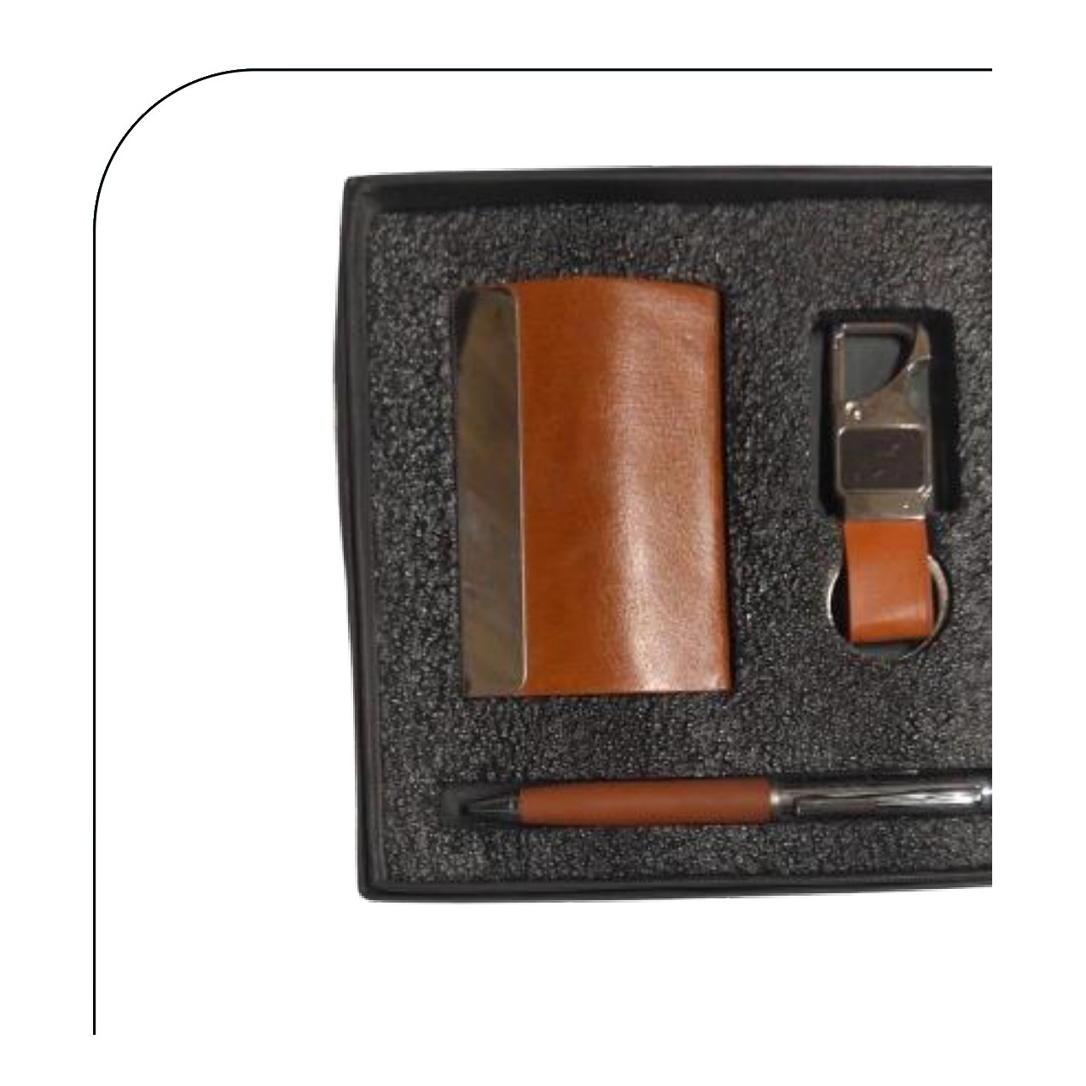  Cardholder · Pen · Keychain  Rs. 218/- (Base Rs.185 + 18% GST) |  | Item No. 10  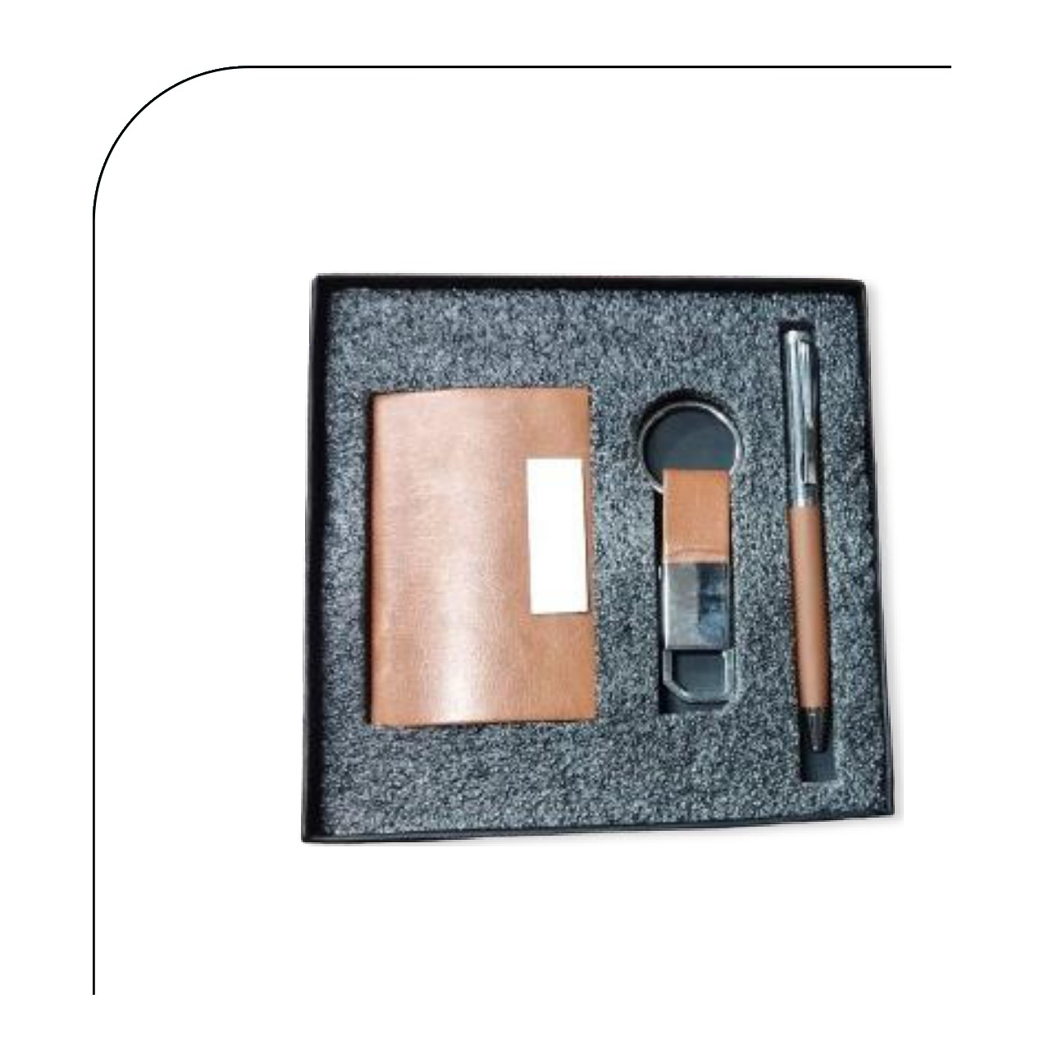  Cardholder · Pen · Keychain  Rs. 171/- (Base Rs.145 + 18% GST)
Item No. 11  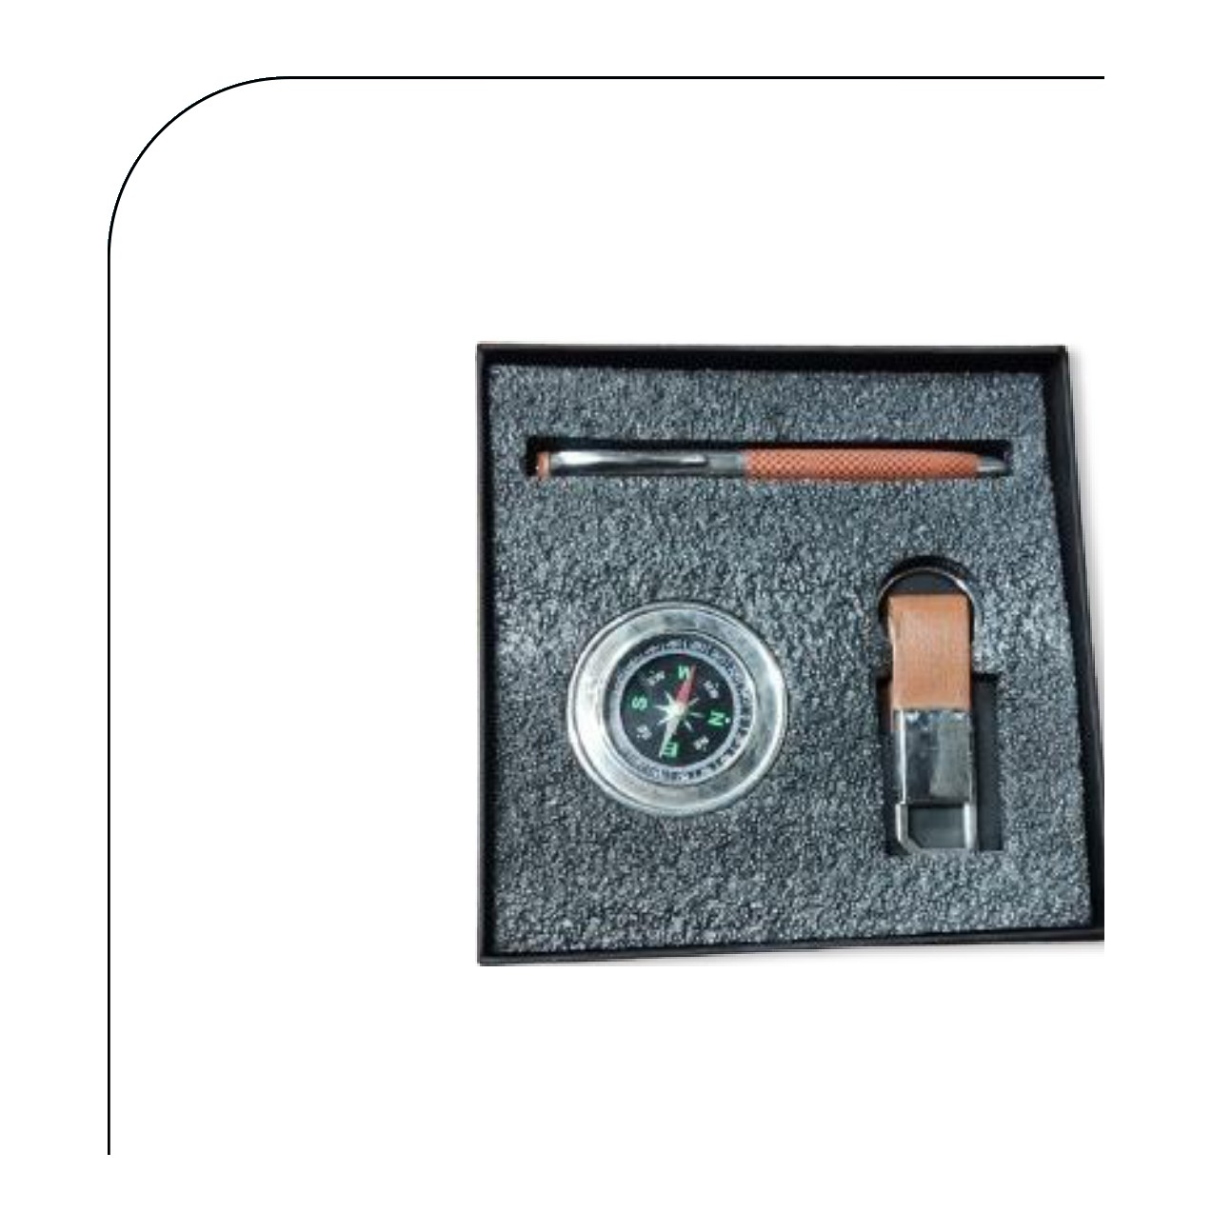  Pen · Compass · Keychain  Rs. 195/- (Base Rs.165 + 18% GST) |  | Item No. 12  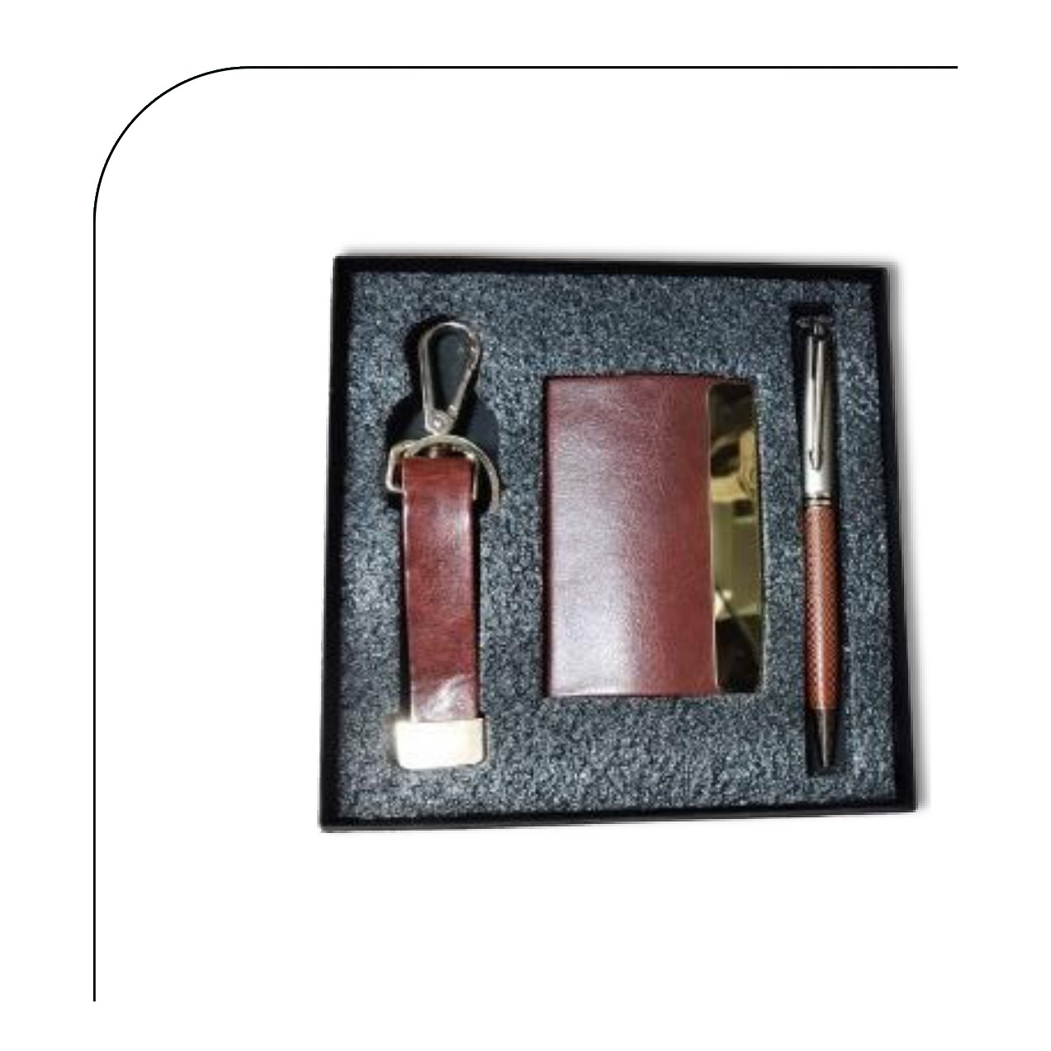  Cardholder · Pen · Keychain  Rs. 236/- (Base Rs.200 + 18% GST)
Item No. 13  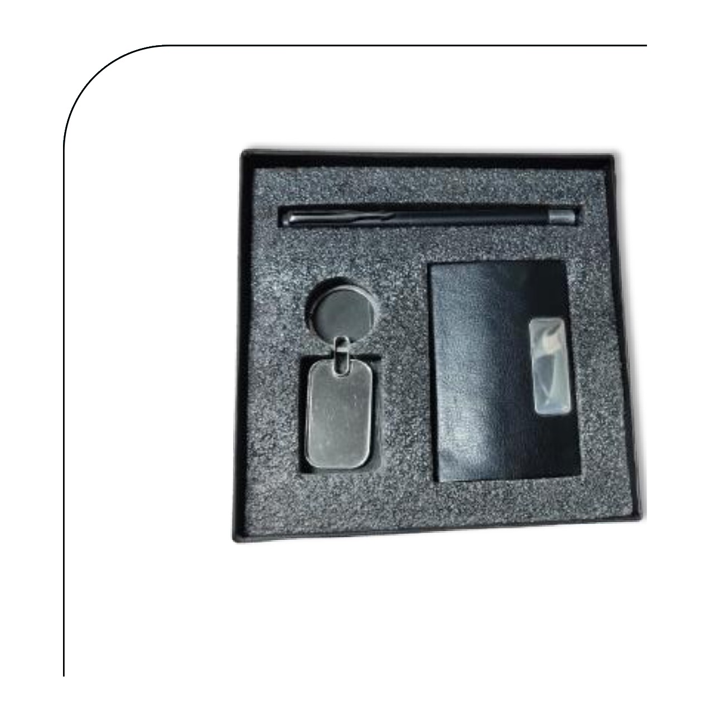  Cardholder · Pen · Keychain  Rs. 159/- (Base Rs.135 + 18% GST) |  | Item No. 14  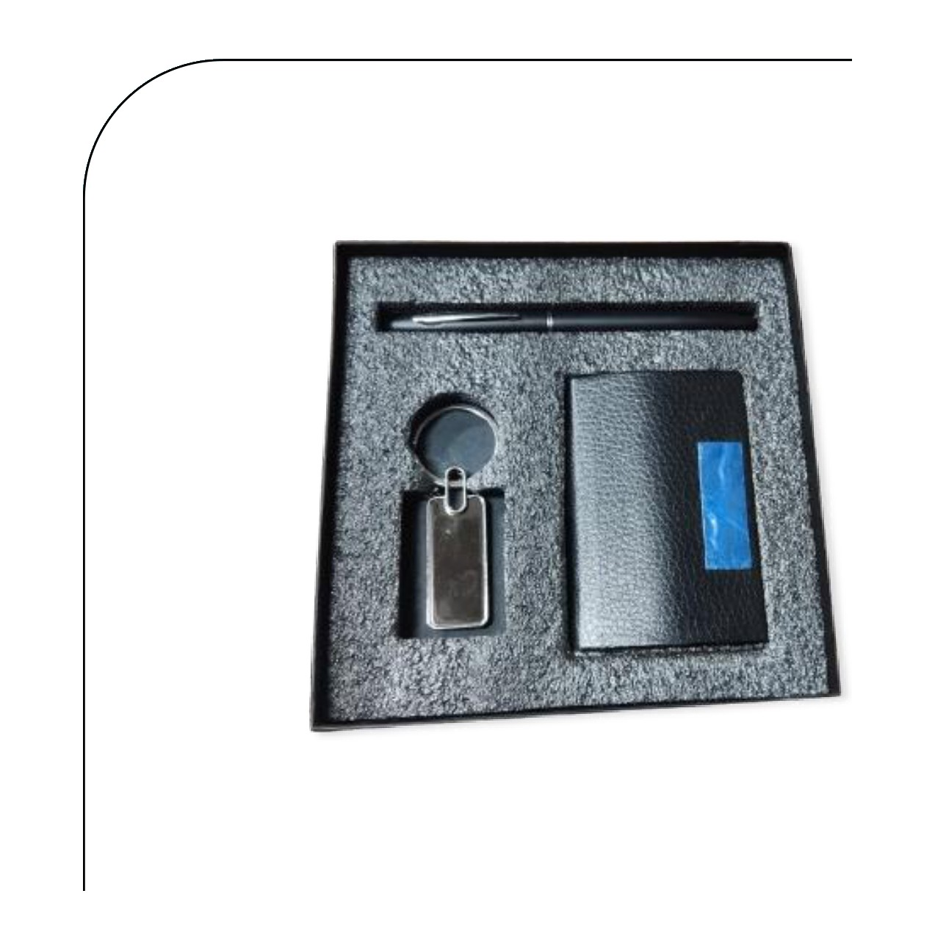  Cardholder · Pen · Keychain  Rs. 159/- (Base Rs.135 + 18% GST)
Item No. 15  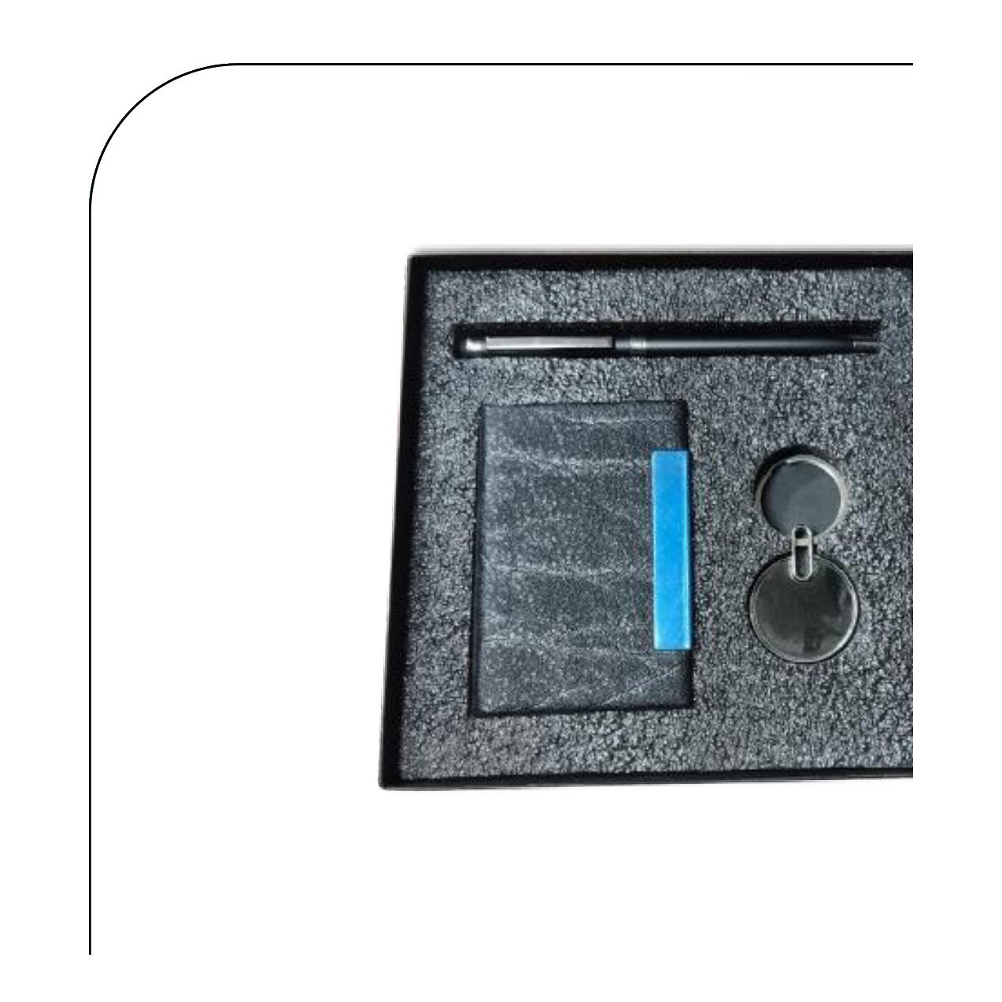  Cardholder · Pen · Keychain  Rs. 171/- (Base Rs.145 + 18% GST) |  | Item No. 16  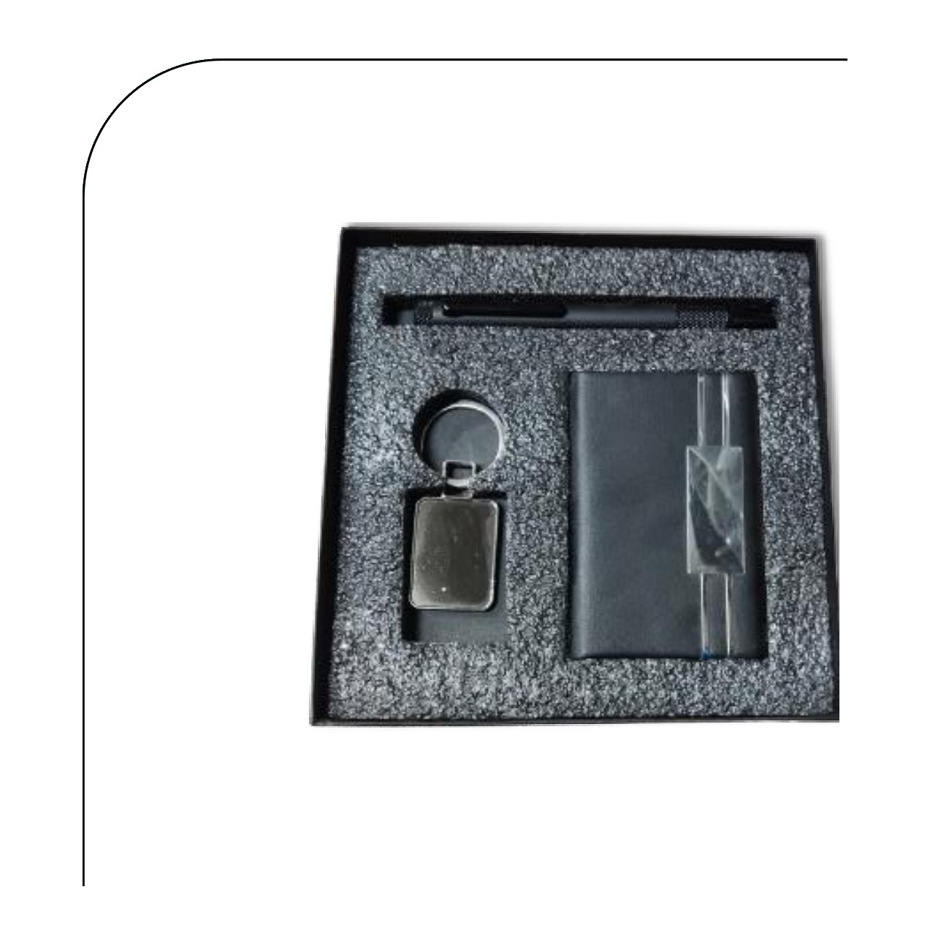  Cardholder · Magic Metal Pen · Keychain  Rs. 212/- (Base Rs.180 + 18% GST)
Item No. 17  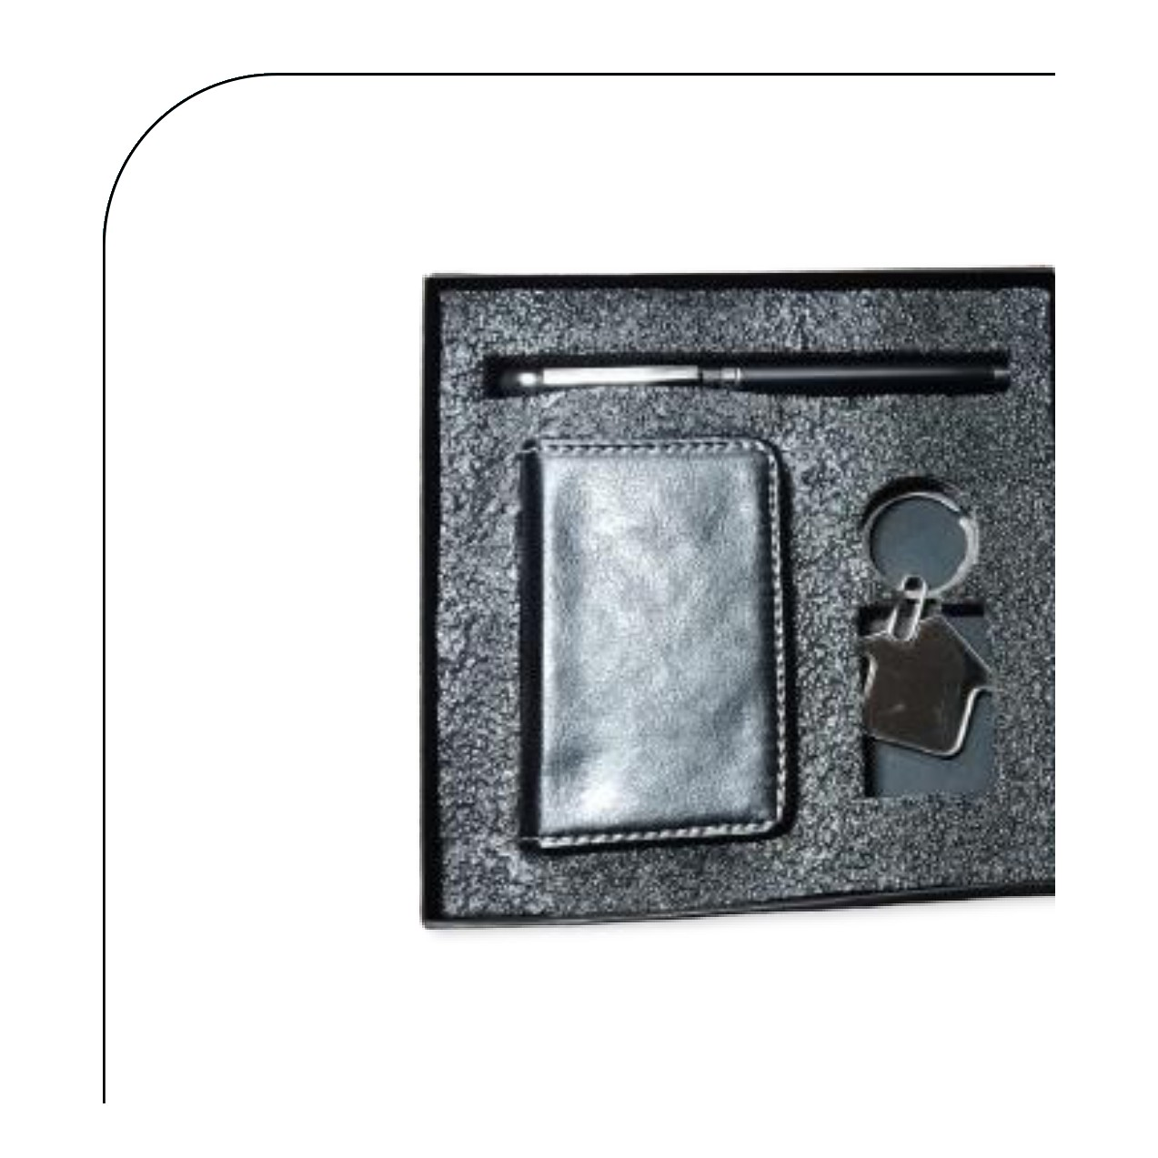  Cardholder · Pen · Keychain  Rs. 195/- (Base Rs.165 + 18% GST) |  | Item No. 18  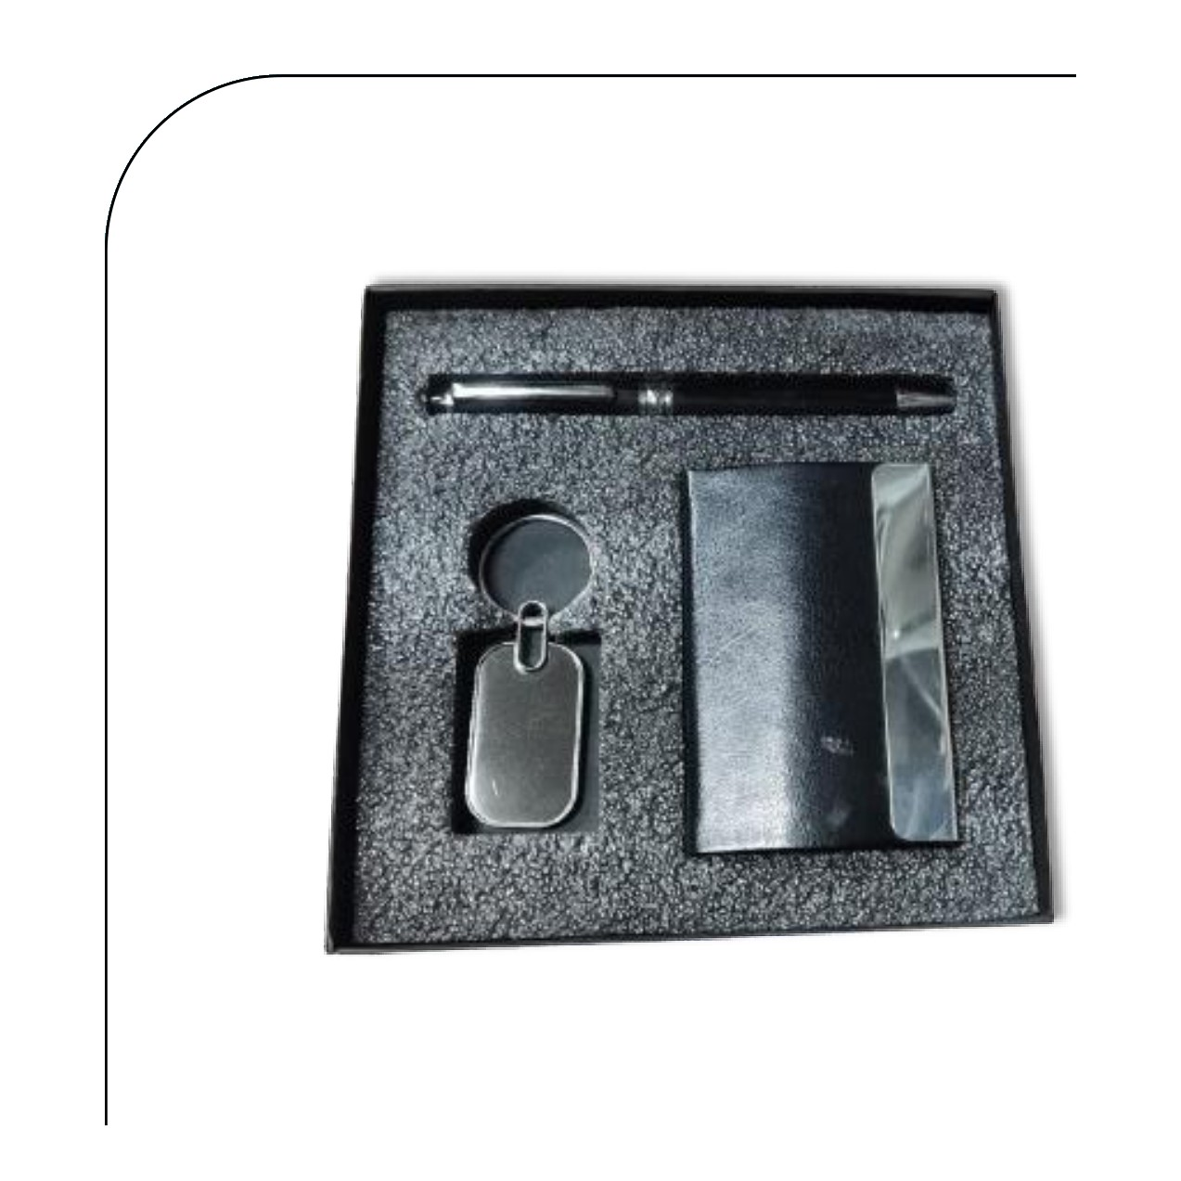  Cardholder · Pen · Keychain  Rs. 159/- (Base Rs.135 + 18% GST)
Item No. 19  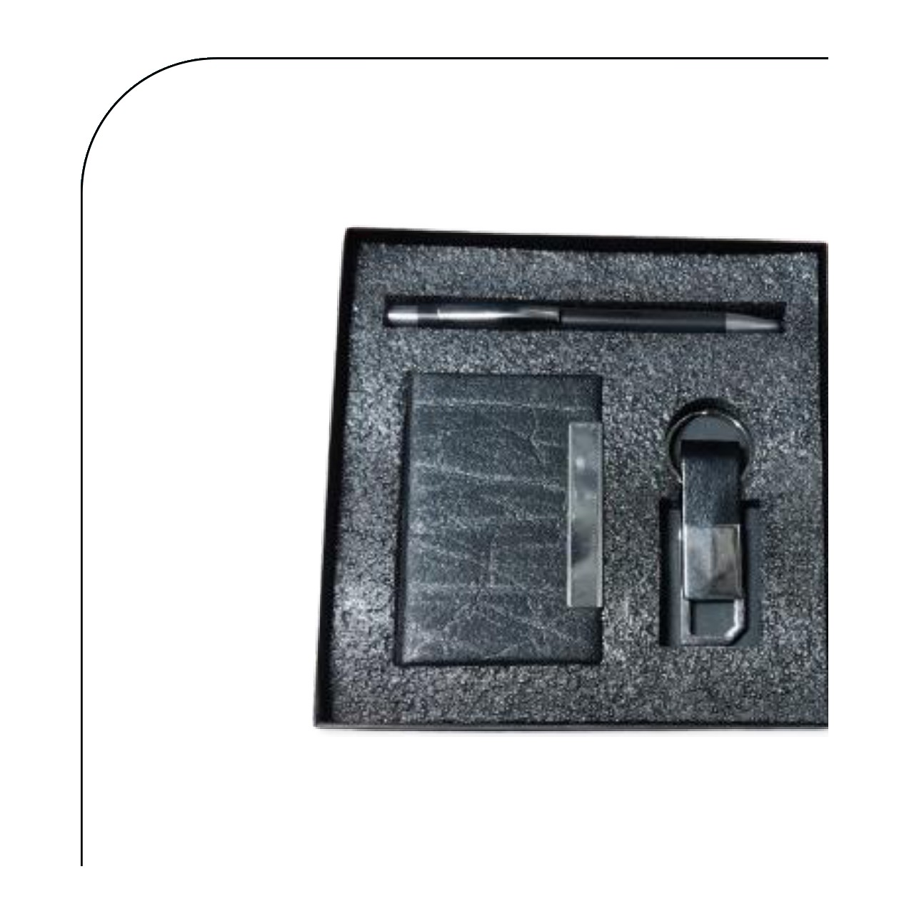  Cardholder · Pen · Keychain  Rs. 177/- (Base Rs.150 + 18% GST) |  | Item No. 20  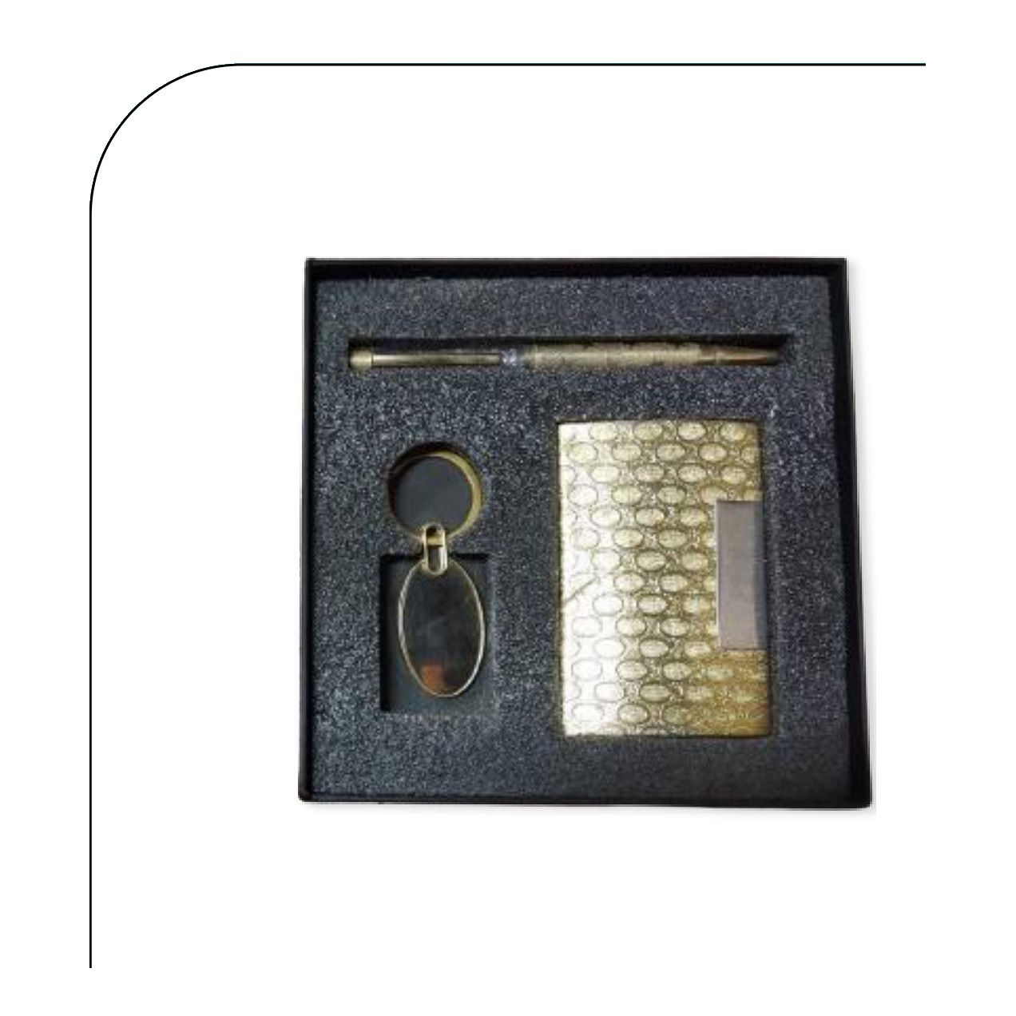  Cardholder · Pen · Keychain  Rs. 195/- (Base Rs.165 + 18% GST)
Item No. 21  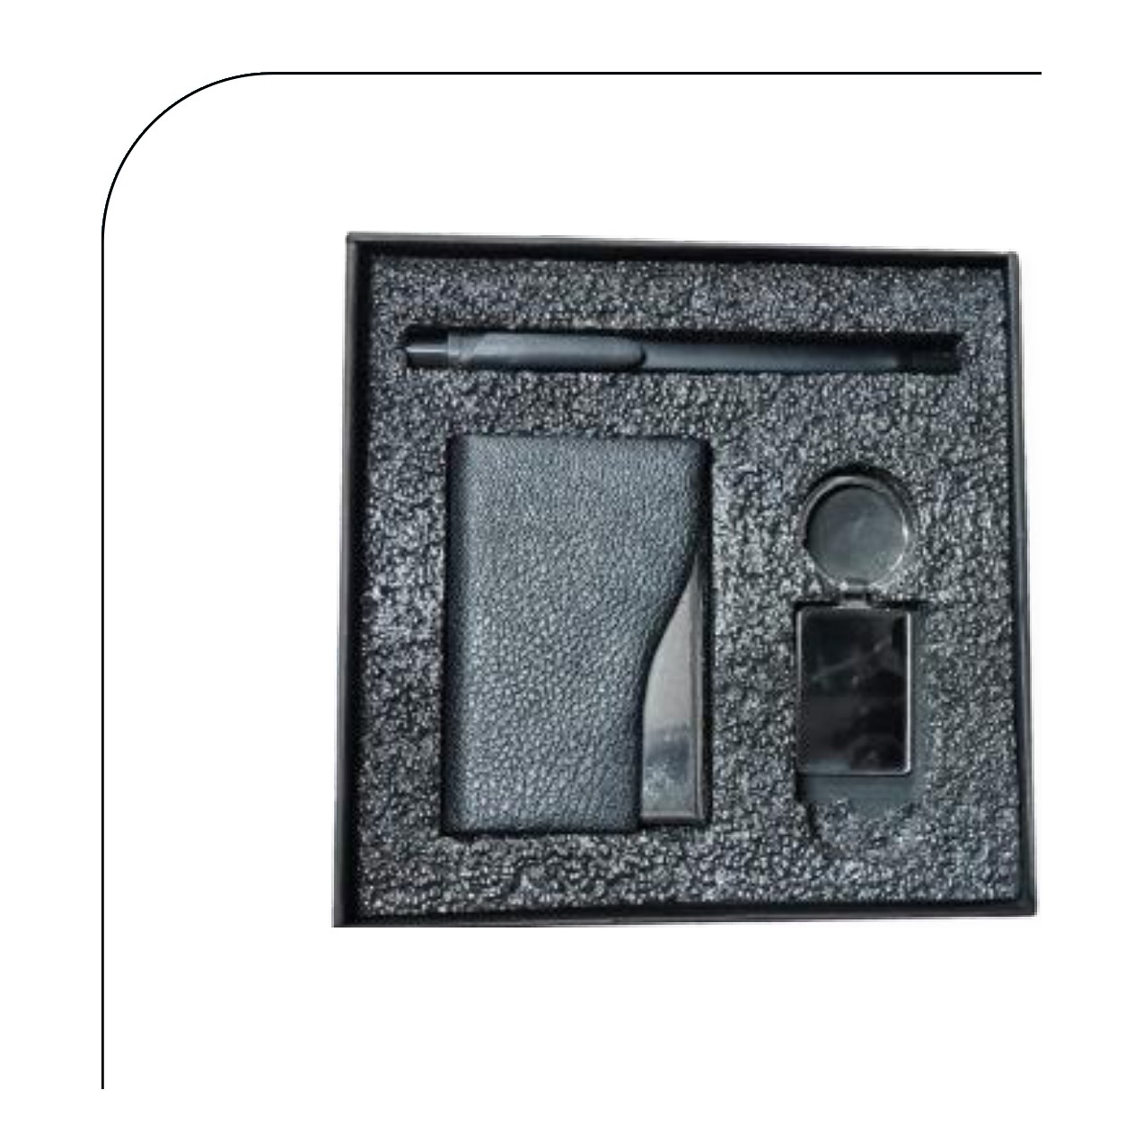  Cardholder · Pen · Keychain  Rs. 165/- (Base Rs.140 + 18% GST) |  | Item No. 22  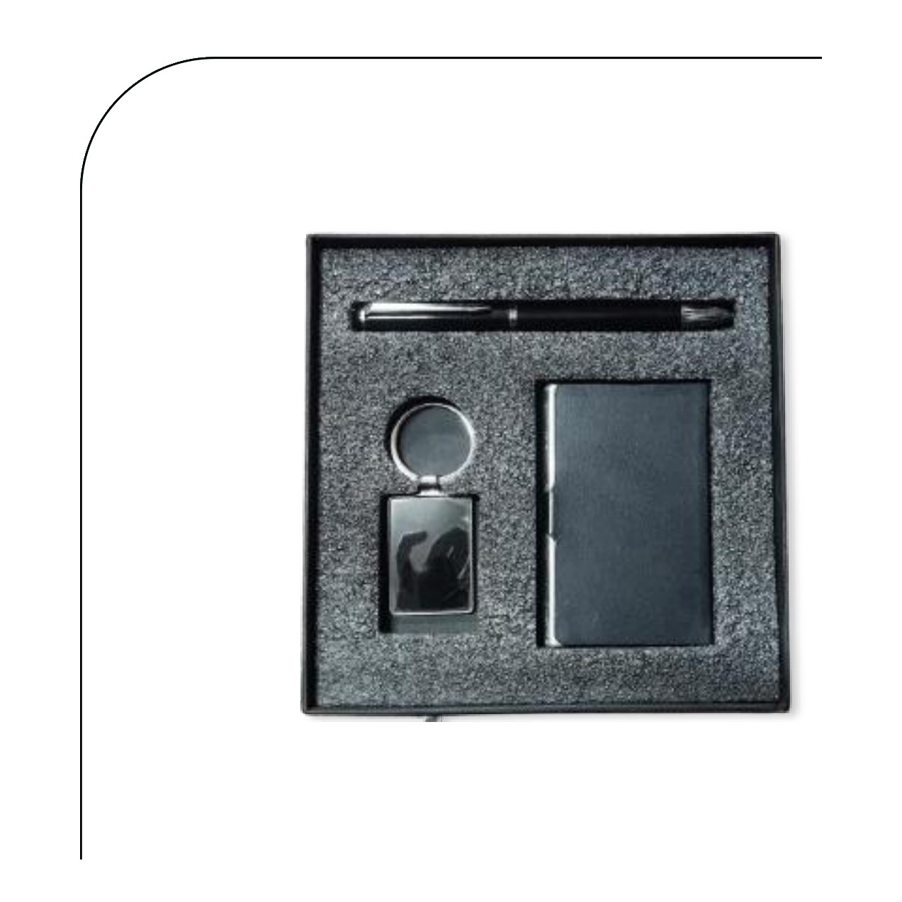  Cardholder · Pen · Keychain  Rs. 153/- (Base Rs.130 + 18% GST)
Item No. 23  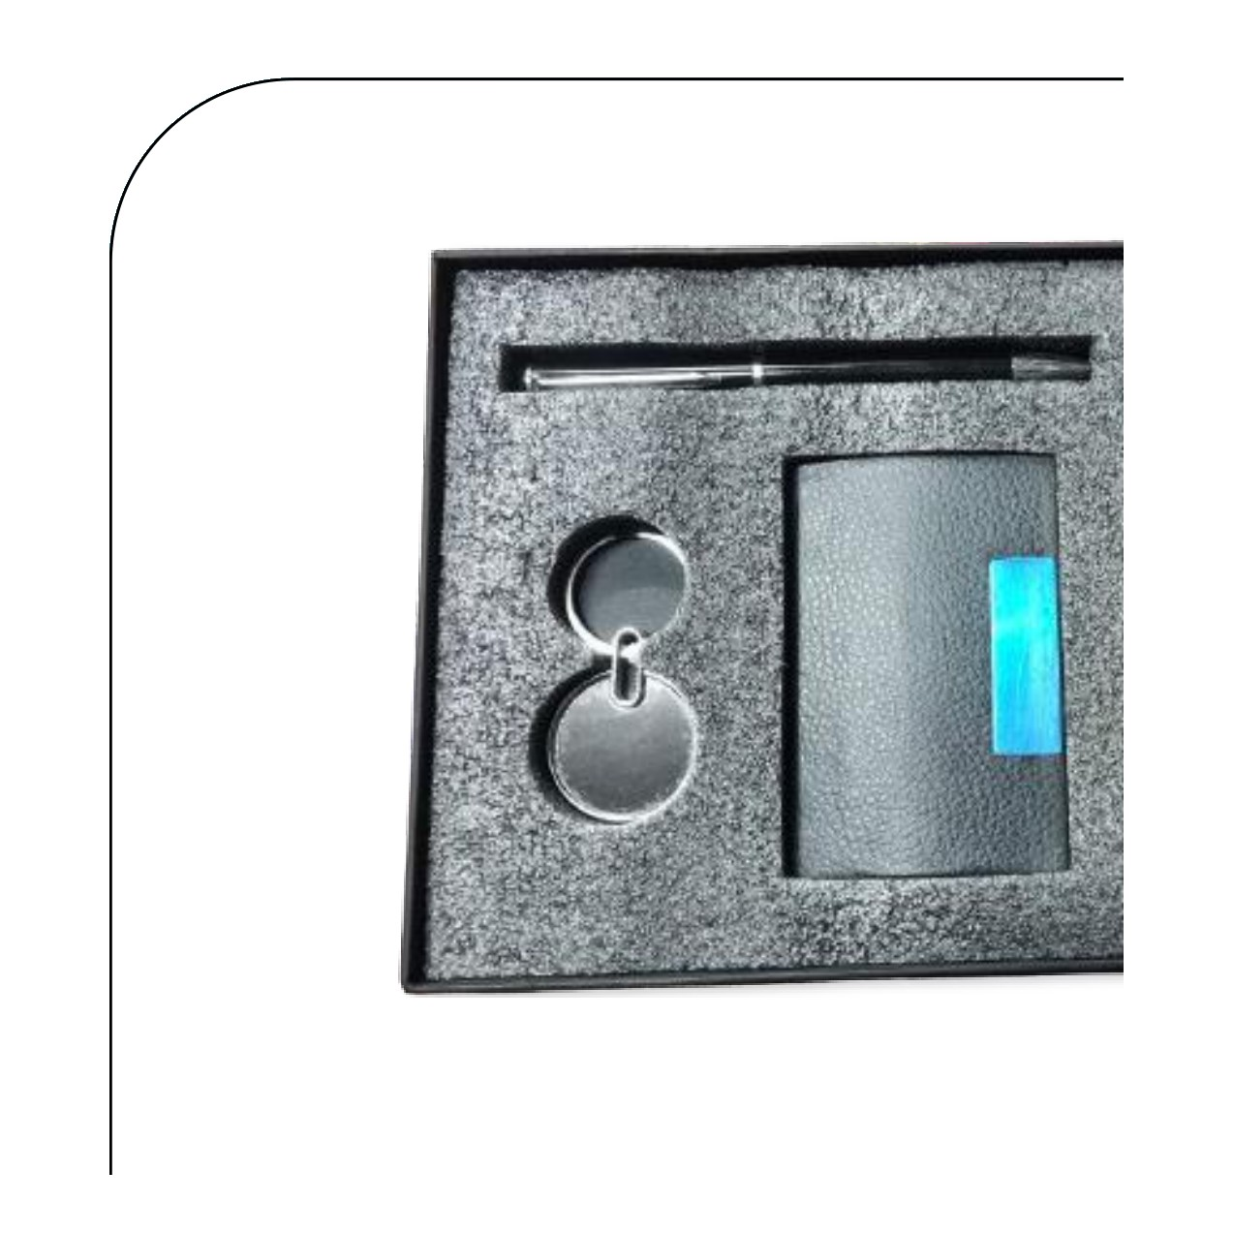  Cardholder · Pen · Keychain  Rs. 153/- (Base Rs.130 + 18% GST) |  | Item No. 24  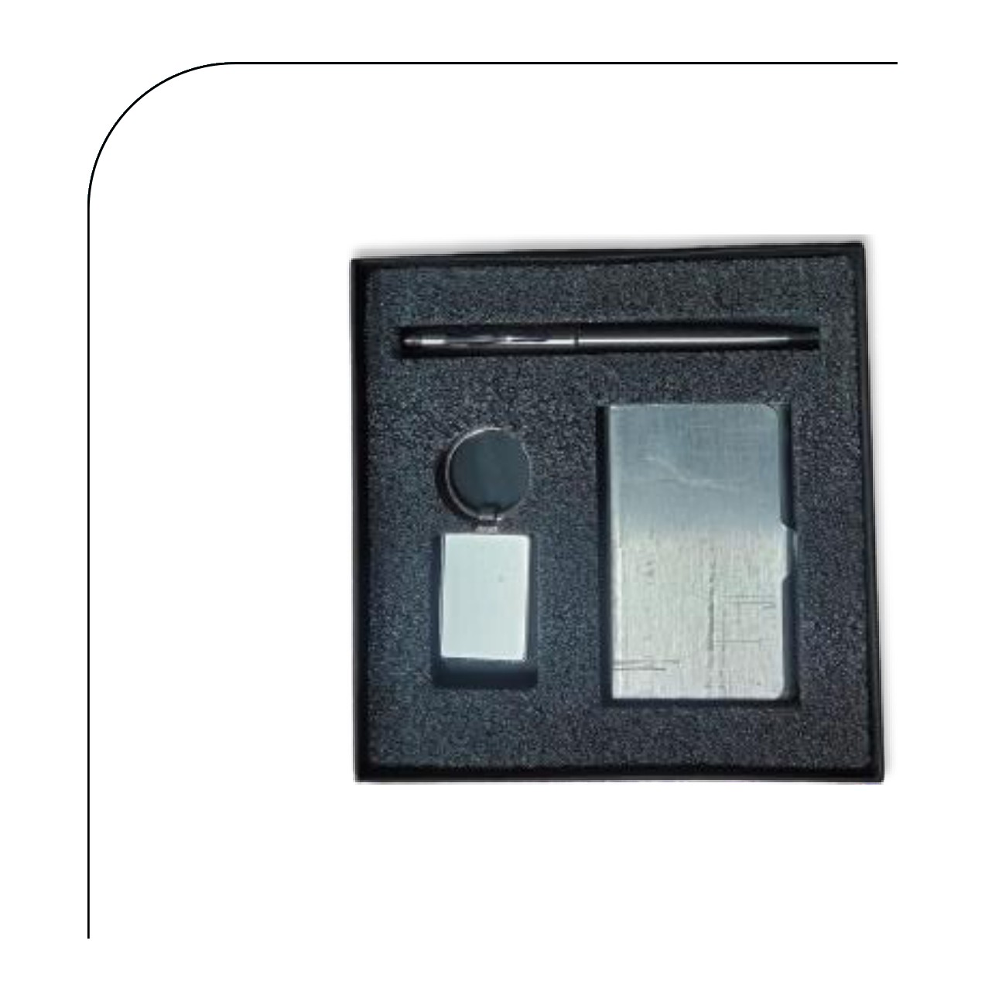  Cardholder · Pen · Keychain  Rs. 142/- (Base Rs.120 + 18% GST)
Item No. 25  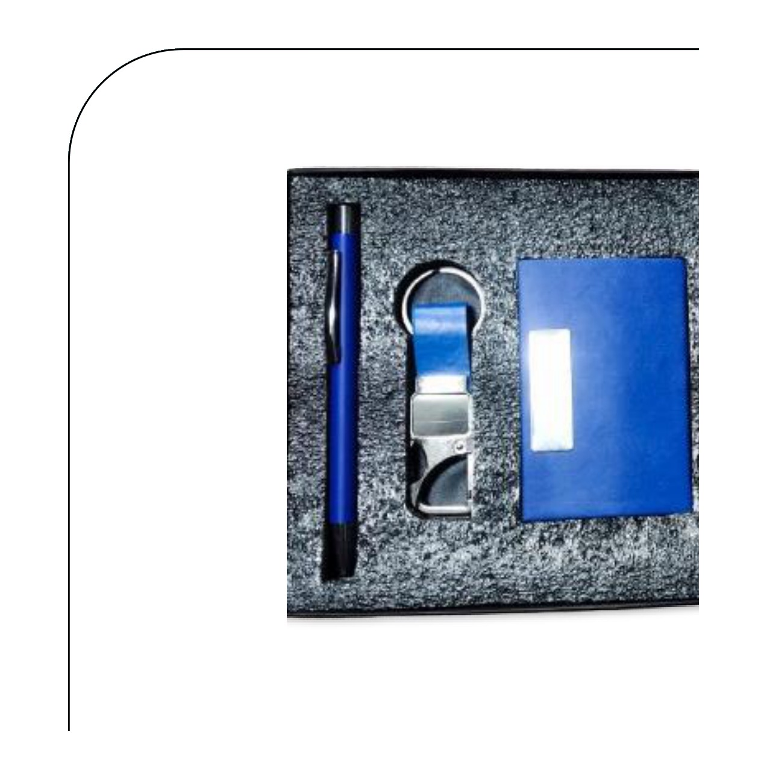  Cardholder · Pen · Keychain  Rs. 171/- (Base Rs.145 + 18% GST) |  | Item No. 26  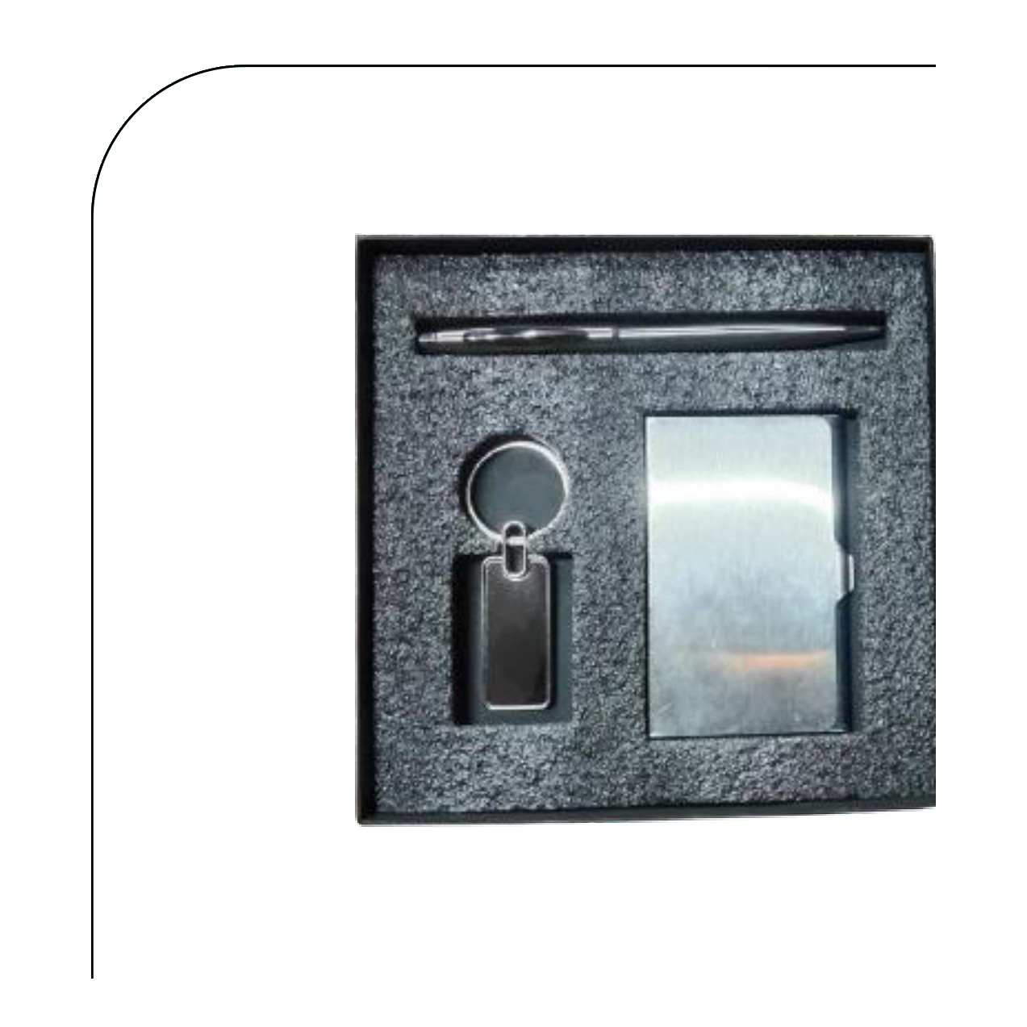  Cardholder · Pen · Keychain  Rs. 130/- (Base Rs.110 + 18% GST)
Item No. 27
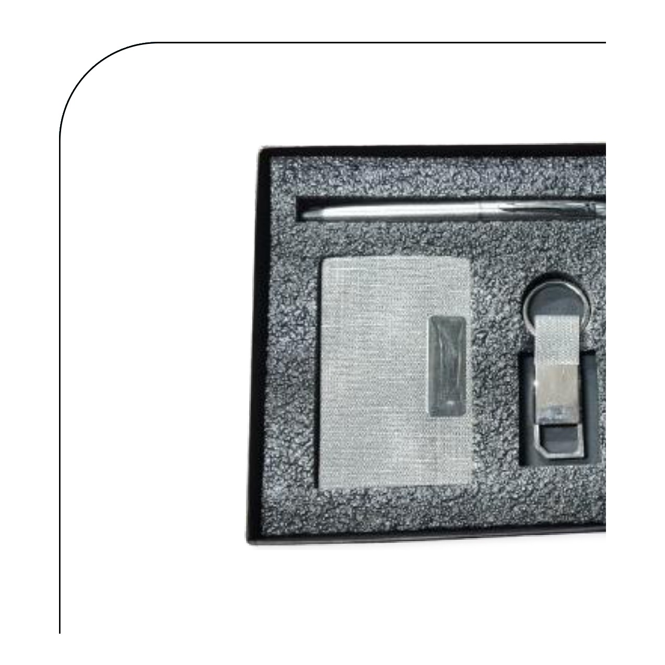
Cardholder · Pen · Keychain
Rs. 177/- (Base Rs.150 + 18% GST)
Thank you
for considering Robust Gifting

All items available for custom branding.
Minimum order quantities and lead times on request.
Prices are exclusive of 18% GST. Valid 2026.

